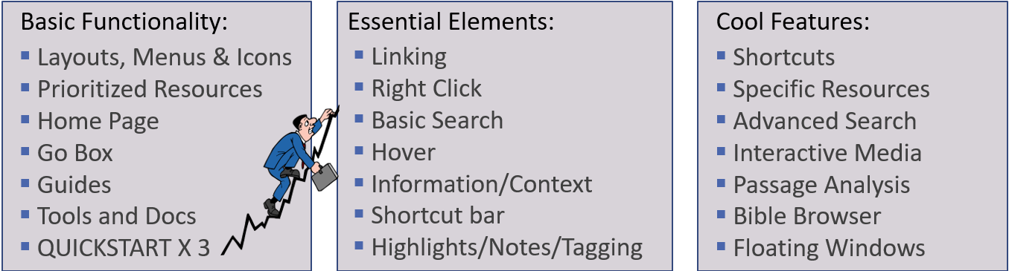

Review the Instrument Panel
- Top 4

  - Factbook
  - GO BOX
  - Shortcuts Bar
  - Layout Menu (Quickstart, Homepage, Saved/Tailored layouts)

Review the Panel Menu
- Buttons: Sidebar, Navigation, Location, inline search, visual filters, factbook, interlinear, multiple resources, parallel resource sets, navigation arrows, panel history, panel menu
- Panel Menu Button ($⋮$) –

  - Set Resource Font Size
  - Set linksets
  - Show Locator Bar
  - Print/Export
  - Show Columns/Set Columns
  - Resource Information
  - Reading View

Prioritizing your resource
- This is an absolute MUST since it determines the order that your bibles, dictionaries, commentaries, lexicons will show up in guides and parallel resources sets
- From your GO BOX – “Set Preferred Bible to English Standard Bible”
- From your Library – Open Panel Menu and select

Home Page
- Dashboard Section (adding or continuing a course, devotional, layout, lectionary, Prayer List, Reading Plan, Workflow)
- Explore Section (community pricing, sales, Blog articles, verse of the day, From Your Library, training videos, free books/videos, pre-orders)

Basic Guide Introduction
- Big 3: Passage Guide, Exegetical Guide, Bible Word Study

Tools and Docs Introduction
- Docs – Relate to your personal documents, filters and

  - Reading Plans
  - Passage Lists
  - Prayer Lists
  - Visual Filters

- Tools
  - Atlas, Factbook, Faithlife, Notes, Passage Analysis, Text Comparison
  - Bible Browser Quicklook

Bible Study Workflows (in the Guides Menu); Workflows – Logos Help Center
- Basic Bible Study
- Inductive Bible Study

References and Help Support:
- Go with Mo!
  - Use the 15 Quickstart Videos as a starting point for orientation and an ongoing resource for Logos familiarization
    - QUICKSTART (e.g. Type: Open QuickStart for Logos 9 in GOBOX)
  - Monthly Webinars: Getting on MPSeminars distribution list allows you to get invites for more in depth review of features—that remain available for a limited time (if you register). You should be able to signup with MP Seminars via their Faithlife Group: Morris Proctor Seminars - Faithlife
  - MPSeminars subscription -
- Logos Help Center: Logos Help Center
  - Includes a Logos Mobile App section – thought I recommend you focus on getting familiar with the desktop version first
  - Really Good: 1. Get Oriented in Logos – Logos Help Center
  - Logos Bible Software Wiki: Logos Bible Software Wiki
  - Logos Blue Box Short Videos on the Home Page Explore Section
  - Logos 9 Advanced Bible Study Series: Logos 9 Advanced Bible Study Series – Logos Help Center
- My YouTube Page
  - Includes two Logos videos for getting started and powerful search options. Also included is a summary of features for free web based tools
  - Kirk Streitmater - YouTube
- My Logos Page
  - Includes getting started slides, searching slides, and some zoom sessions.
  - Logos - hagiazo.net
- Additional Links
  - Faithlife TV Logos training link: Logos Training - Faithlife TV
  - Logos Keyboard Shortcuts: Keyboard Shortcuts – Logos Help Center
- Facebook Page for Logos Tips and Tricks
  - Perhaps the best / easiest / fastest help desk option available if you are on Facebook. Includes 10,000 members with people happy to provide their Logos expertise and opinions on the full range of topics related to the software.
  - Logos Tips and Tricks
  - Note: The parent group is called Logos Daily and I am working with them on their coaching program

